**Project Title – “Smart Subscription Tracker”**

**Phase 3: Data Modeling & Relationships**

* **Standard & Custom Objects**
* **Account (Standard): Represents customers or businesses.**
* **Contact (Standard): Stores customer contact persons.**
* **Subscription__c (Custom): Tracks subscription contracts (start/end dates, type, status). Linked to Account.**
* **Payment__c (Custom): Records payments (date, amount, mode, status). Linked to Subscription__c.**

**Data Flow:  
Account → Contact → Subscription__c → Payment__c**

* **Master-Detail Relationship**

To ensure subscriptions are tightly linked to customers, a Master-Detail relationship was created between Subscription__c and Account.

* Master Object: Account
* Detail Object: Subscription__c
* Why: Subscriptions always belong to an Account, and record ownership/sharing should follow the Account owner.

Steps Taken:

1. Setup → Object Manager → Subscription → Fields & Relationships → New.
2. Selected Master-Detail Relationship.
3. Chose Related To: Account.
4. Labeled field as Account (API: Account__c).
5. Kept default sharing so child inherits parent.
6. Saved configuration.

* **Fields for Subscription__c**

To capture essential subscription details, the following custom fields were added under Fields & Relationships:

* Subscription Number (Subscription_Number__c): Auto-Number, format SUB-{0000}.
* Plan: Lookup to Product2 (or picklist if simpler).
* Start Date (Start_Date__c): Date, required on layout.
* End Date (End_Date__c): Date.
* Status (Status__c): Picklist with values *Draft, Active, Renewed, Expired, Canceled* (default: Draft).
* Billing Frequency (Billing_Frequency__c): Picklist with values *Monthly, Quarterly, Yearly, Weekly, Bi-Annual*.
* Price (Price__c): Currency.
* Payment Status (Payment_Status__c): Picklist with values *Paid, Pending, Failed*.
* Auto Renew (Auto_Renew__c): Checkbox.
* Notes (Notes__c): Long Text Area for additional remarks.

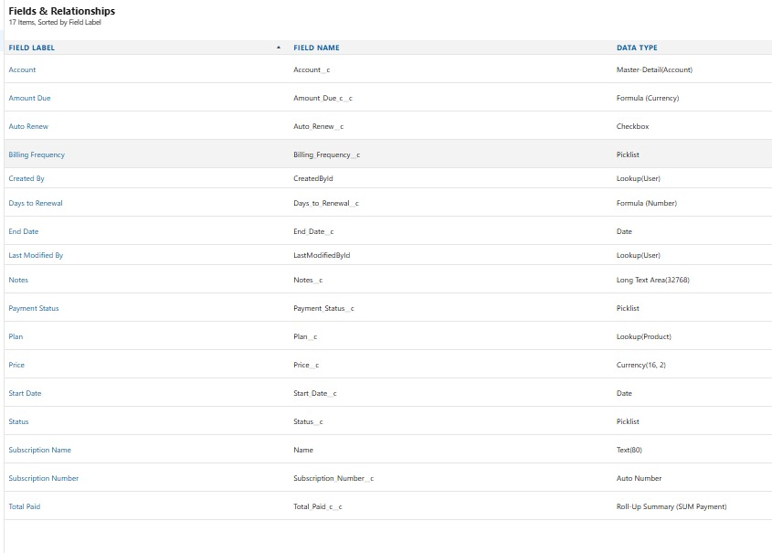

* **Formula and Roll-Up Fields on Subscription__c**

To enhance automation and visibility, the following fields were added:

1. **Days to Renewal (Days_To_Renewal__c):** Formula (Number, 0 decimals).
   1. Formula: IF(ISBLANK(End_Date__c), 0, End_Date__c - TODAY())
   2. Purpose: Calculates remaining days until the subscription end date.
2. **Total Paid (Total_Paid__c):** Roll-Up Summary (requires **Payment__c → Subscription__c** Master-Detail).
   1. Summarizes Payment__c records related to the subscription.
   2. Aggregation: **SUM** of *Amount__c*.
   3. Optional Filter: Include only records where *Payment__c.Status__c = "Paid"*.
3. **Amount Due (Amount_Due__c):** Formula (Currency).
   1. Formula: Price__c - Total_Paid__c
   2. Purpose: Displays outstanding balance for the subscription.

* **Validation Rule on Subscription__c**

To maintain data accuracy, a validation rule was added to ensure subscription dates are entered correctly.

* **Rule Name:** EndDate_After_StartDate
* **Logic:** Prevents users from saving a subscription where the **End Date** is the same as or earlier than the **Start Date**.
* **Error Message:** *“End Date must be after Start Date.”* (displayed on the End Date field).

**Result:** This rule enforces proper contract timelines and avoids errors in renewal and billing calculations.

* **Payment__c Object Setup**

The **Payment__c** object was created to track customer payments against subscriptions and enable financial reporting.

* **Object Creation:**  
  Custom Object → **Payment** (API: Payment__c), plural: Payments, with reporting enabled.
* **Relationship:**  
  A **Master-Detail** relationship links each Payment to a **Subscription__c** record.
  + Ensures payments inherit access from their subscription (and ultimately from the account).
  + Enables roll-up summaries such as “Total Paid” at the subscription level.
* **Core Fields:**
  + **Amount (Amount__c):** Currency, required.
  + **Payment Date (Payment_Date__c):** Date.
  + **Method (Method__c):** Picklist — Card, ACH, Cash, Other.
  + **Status (Status__c):** Picklist — Paid, Pending, Failed, Refunded.
  + **Transaction ID (Transaction_ID__c):** Text (255).
  + **Notes (Notes__c):** Long Text Area.

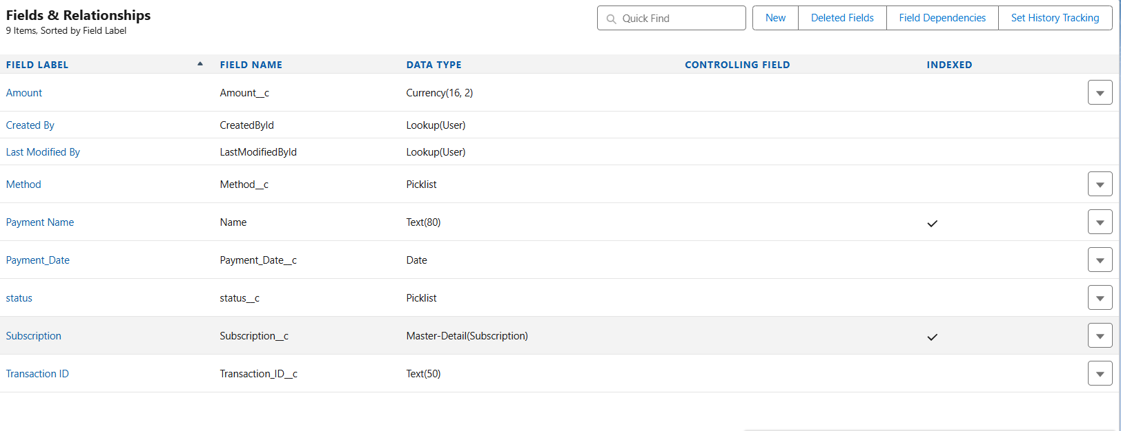

* **Page Layouts — Subscription & Payment**

To make the system user-friendly and ensure key data is visible at a glance, customized page layouts were configured for **Subscription__c**, **Payment__c**, and **Account**.

* **Subscription Page Layout:**
  + Organized fields into clear sections: Header (compact), and Details (Start Date, End Date, Status, Frequency, Price, Auto Renew).
  + Added the **Payments related list** with buttons (*New, Edit*) and columns (*Amount, Payment Date, Status*).
* **Payment Page Layout:**
  + Included fields: Subscription (master-detail), Amount, Payment Date, Method, Status, Transaction ID, and Notes.
  + Provides a complete view of each payment record tied to its subscription.
* **Account Page Layout:**
  + Added **Subscriptions related list** to Accounts.
  + Configured columns to display Subscription Number, Status, and End Date for quick visibility at the account level.

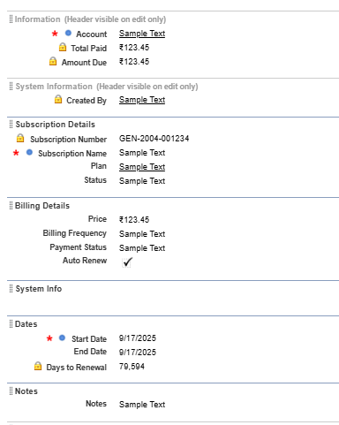

* **Compact Layouts — Subscription & Payment**

To improve visibility in the **highlights panel** (desktop) and on **Salesforce mobile**, compact layouts were created for key objects.

* **Subscription Compact Layout:**
  + Fields displayed: Subscription Number, Status, End Date, Price.
  + Assigned as the **Primary Compact Layout** for Subscription__c.
* **Payment Compact Layout:**
  + Fields displayed: Amount, Payment Date, Status.
  + Assigned as the **Primary Compact Layout** for Payment__c.

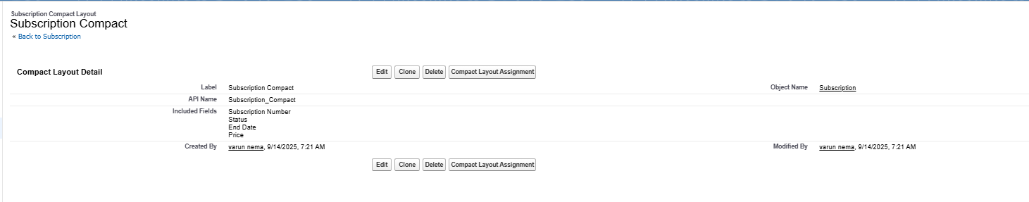

* **Record Types:**

Not used in this project because all subscriptions follow the same process and layout, so separate record types are unnecessary.

* **Schema Builder:**

**Sir, I am unable to view the relationships in Schema Builder, even after following all the steps.**

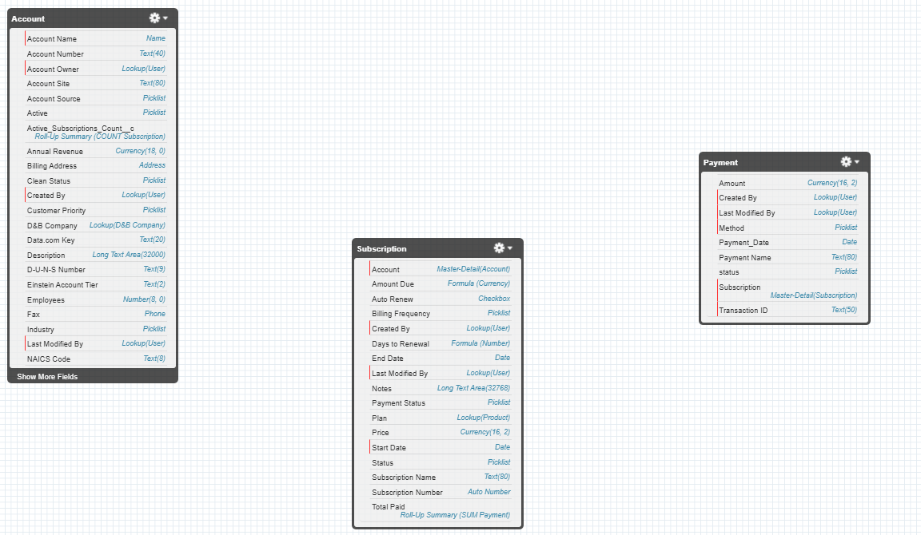

* **Junction Objects:**

Not used because the project does not require a many-to-many relationship. Subscriptions and Payments already have clear one-to-many relationships, so junction objects are unnecessary.

* **External Objects:**

Not included since the project does not integrate with external systems or data sources. All required data is stored within Salesforce standard/custom objects.

* **Validation rules:**
* **Validation Rule Name**: EndDate_After_StartDate
* **Purpose**: Ensures data integrity by preventing users from saving subscriptions where the End Date is earlier than or equal to the Start Date.
* **Error Condition Formula**:  
  The rule checks that both Start Date and End Date fields are not blank, and then validates that End Date is greater than Start Date.
* **Error Message**: Displays “End Date must be after Start Date” when the condition fails, guiding users to correct the entry.
* **Error Location**: Error is shown on the End Date field to help users identify exactly where the issue lies.
* **Description**: Adds a safeguard in the system to maintain logical subscription timelines.
* **Status**: The rule is active, meaning it is currently enforcing this validation in the system.
* **Audit Info**: Created and modified by varun nema on September 13, 2025, 12:37 PM.

